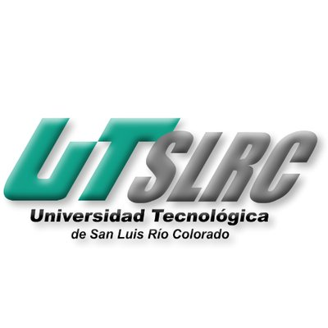

**UNIVERSIADAD TECNOLÓGICA DE**

**SAN LUIS RIO COLORADO**

**REINVENT OURSELVES**

**MTRO. VLADIMIR AHMED GALINDO ZENDEJAS**

**AUTOR: VICTOR MANUEL GALVAN COVARRUBIAS**

San Luis Rio Colorado, Sonora Mayo, 2020

The intangibles are those aspects that change whit the perception of the person. Everyone has different intangibles and the intangibles mean that present connection that we make ourselves with people in one or more groups. It does not matter how distinct the culture, the language and the clothing are, humans are always looking for some similarity in the people that surround us.

If a group or a team is created and they have to accomplish an objective, it is more probable that the objective is accomplish if the participants in that group have some or various things in common. It may be for some animal wild instinct that we are always looking for belonging and acceptance from others.

As the video says if you travel to another city, country or continent in some point you are going to encounter with a person that will have similarities with you and in that moment a connection will take place on both parts. It is more likely that the other person starts to feel empathic with you because it remembers something about them. And it does not have to be a big and important thing in common, just with a little detail it will be enough for that person and it will treat you differently.

In a group or a team this is very important because it will provide stability to the people and will assure the correct work of every part and member. This is because the easiest aspects to see in another person in common are the ones the everybody has like the race, the nationality, the spoken language, the culture, etc.

All this comes from the tribalism and ancient human behavior that was based on tribes. Our ancestors sought that tribalism to ensure survival.

Thinking in the seen in the video, we can say that the intangibles are those things that are not material but the aspects in common that each person has with another and how those aspects help us form new friendships or relationships around the world.

The companies and us need a reinvention, to start seen the intangibles. In this way the political and social division will come to an end, from there we can focus in the important things that are going to raise our quality life, and prevent times like the ones we are currently living.